Magnetic field

Every magnet has a magnetic field.
The magnetic field fills the space around a magnet.

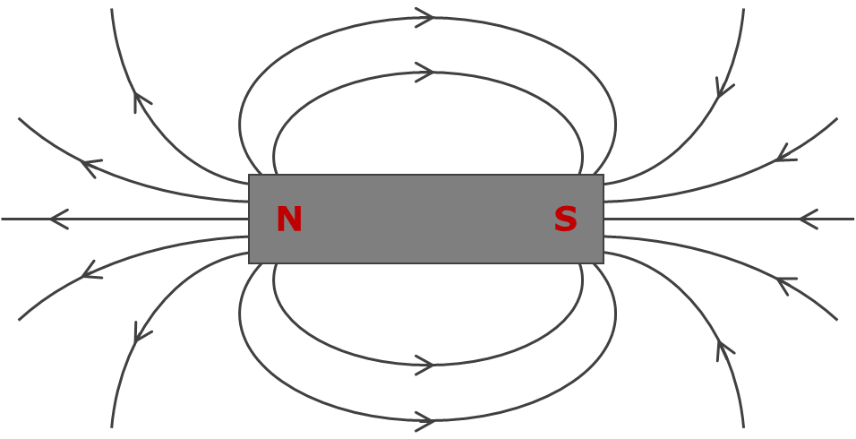

What do you think a magnetic field does?
For each statement, tick (✓) one column to show what you think.
 |  | I am sure this is right | I think this is right | I think this is wrong | I am sure this is wrong
A | It pulls magnetic objects before the magnet touches them.
B | It attracts tiny pieces of tissue, like a balloon with an electric charge can do.
C | It can push other magnets away before the magnet touches them.
D | It stops a few centimetres from the magnet.

Physics > Big idea PEM: Electricity and magnetism > Topic PEM3: Magnets and electromagnets > Key concept PEM3.1: Magnetic fields
Diagnostic question
Magnetic field

Overview
Learning focus: | The magnetic field around a magnet can be represented by field lines, which indicate the size and direction of the force of the magnet on the north-seeking-pole of another magnet.
Observable learning outcome: | Describe the properties of a magnetic field.
Question type: | Confidence grid
Key words: | Magnetic field, attract, repel

What does the research say?
Younger children often think of magnets as ‘sticking’ to objects, rather than attracting objects from a distance (Driver et al., 1994; Bradamante and Viennot, 2007). They may also think that the strength of a magnets is determined by its size, with bigger magnets being stronger than smaller ones (Borges and Gilbert, 1998).
Borges and Gilbert (1998) unpicked how students aged 15 (n=9) and 18 (n=19), teachers (n=11), technicians (n=10) and electrical engineers (n=7) thought about magnetism. They found evidence of three models of understanding that Erickson described (1994) and identified two further models, which encompassed more advanced thinking. They found that all of the 15-year-olds in their study held one or more of the first three models. The first model merely labels the observed effects of a magnet; and the second and third contain common misunderstandings:-
- Magnetism as a pull – describing what magnets do, rather than what they are.
- Magnetism as a cloud – an area of influence around a magnet that can act on other objects.
- Magnetism as electricity – described as an attractive force between unlike electric charges and a repulsive force between like electric charges.
The understanding of magnetism as electricity appears to be caused by the earlier teaching of static electricity. The similarities between the terminology used in magnetism and in electrostatics can also cause confusion. Some students, for example, refer to the positive pole and the negative pole of a magnet. Others described the poles of a magnet as regions with an ‘excess’ or a ‘lack’ of electric charge.
Ways to use this question
Students should complete the confidence grid individually. This could be a pencil and paper exercise, or you could use an electronic ‘voting system’ or mini white boards and the PowerPoint presentation.
If there is a range of answers, you may choose to respond through structured class discussion. Ask one student to explain why they gave the answer they did; ask another student to explain why they agree with them; ask another to explain why they disagree, and so on. This sort of discussion gives students the opportunity to explore their thinking and for you to really understand their learning needs.
Differentiation
You may choose to read the questions to the class, so that everyone can focus on the science. In some situations it may be more appropriate for a teaching assistant to read for one or two students.
Expected answers
Statements A and C are correct.
Statements B and D are wrong.
How to respond - what next?
Most students understand that magnetic fields act at a distance and are likely to identify statements A and C as correct, although some students may not have experienced the repulsive force between two magnets very much, if at all.
Research shows that many students and adults of all ages often think the force of a magnet on objects is caused by static electric charge. For this reason it is likely that a significant number will think that statement B is correct and that a magnet interacts with pieces of tissue in the same way as a charged balloon.
When a magnetic object is picked up with a magnet, the object does not move until the force of the magnet pulling it upward is larger than its weight. For this to be the case the magnet needs to be within a certain distance from the object. This observation can wrongly lead students to think that a magnetic field extends only to this distance. Drawings of magnetic field patterns are usually not drawn more than a short distance from a magnet, which can reinforce this misunderstanding.
If students have misunderstandings about the properties of a magnetic field, it can help to give students hands on experience of testing a range of magnets of different strengths and to compare each magnet’s ability to pick up magnetic object of different sizes. Students could be challenged to develop their own set of rules for magnetic fields based on this investigation, which would work for any magnet.
The following BEST ‘response activities’ could also be used in follow-up to this diagnostic question:
- Response activity: Plotting magnetic fields
- Response activity: Turning magnets
Acknowledgments
Developed by Peter Fairhurst (UYSEG).
Images: Peter Fairhurst (UYSEG).
References
Borges, A. T. and Gilbert, J. K. (1998). Models of magnetism. International Journal of Science Education, 20(3), 361-378.
Bradamante, F. and Viennot, L. (2007). Mapping Gravitational and Magnetic Fields With Children 9-11: Relevance, difficulties and prospects. International Journal of Science Education, 29(3), 349-372.
Driver, R., et al. (1994). Making Sense of Secondary Science: Research into Children's Ideas, London, UK: Routledge.
Erickson, G. (1994). Pupils' understanding of magnetism in a practical assessment context: The relationship between content, process and progression. In Fensham, P., Gunstone, R. & White, R. (eds.) The Content of Science: A Constructivist Approach to its Teaching and Learning. London: Falmer Press.

